2020 Objectives

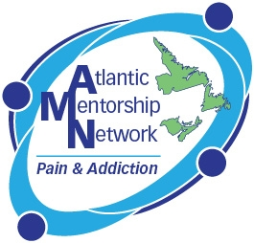

Perspectives in Pain & Addiction: Seeing all Sides' Conference

This conference provides an update on pain and addiction management for physicians, nurses, health care professionals, medical residents and students who have an interest in chronic pain and addiction.

Following the conference participants will be able to:
- Recognize benefit to working as a collaborative team in pain and addiction care for both patients and health care providers.
- Provide examples of current collaborative approaches to pain and addiction care.
- Develop innovative strategies to optimize patient access to care for pain and addiction.

